**Configuring maven in Jenkins:**

* We need to configure git local repo at the location of pom.xml
* We need to add maven location in global tool configuration
* We need to commit all pom.xml also to git repo
* Then we need to use the local repo location as git location in job

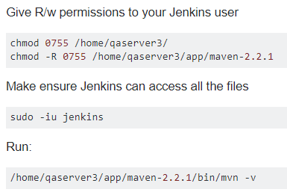

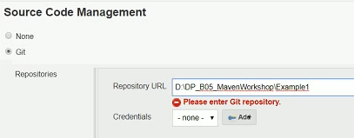

* Under build section, we need to select invoke maven targets and give the goals

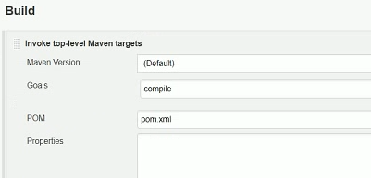

* After the build, it stores the target folder in workspace. As Jenkins runs the job in workspace directory
* If we install maven integration plugin, we can see the maven project option while creating the job

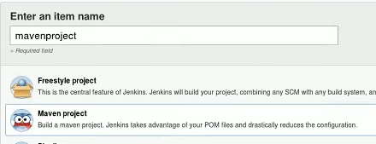

* We need to give our git repo location
* Here, now we can see the room pom option. We can give the pom.xml file location if it is in different location other than git local repo location
* We can do it with maven project or from free style project, free style project can be used for any type of project

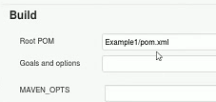

* We can configure the job for nexus deploy by using the settings.xml

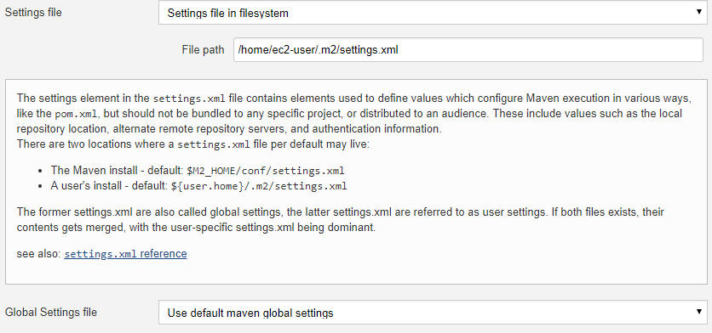

**Nexus in Jenkins:**

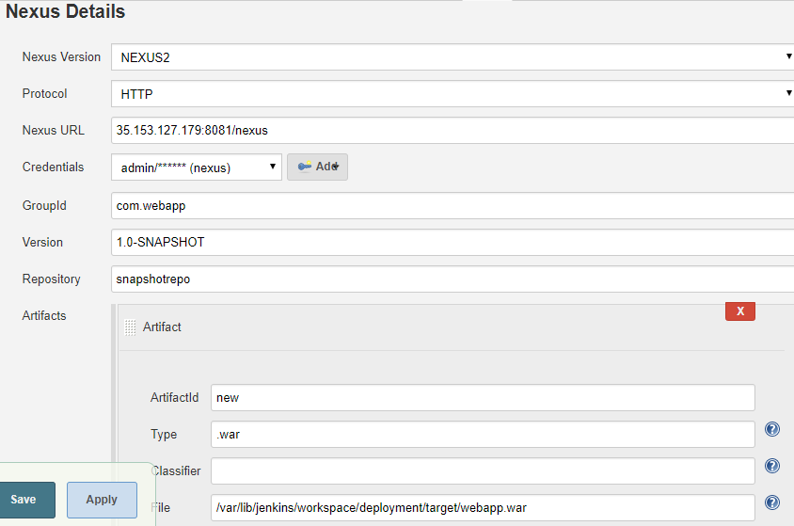

* Under build step. Select nexus artifact uploader and give the details as above
* We get the option when we install nexus plugin in Jenkins
* As above, whatever the war file name is. It will be deployed in nexus as the name which we have given as artifactId along with version and type

**Jenkins with S3:**

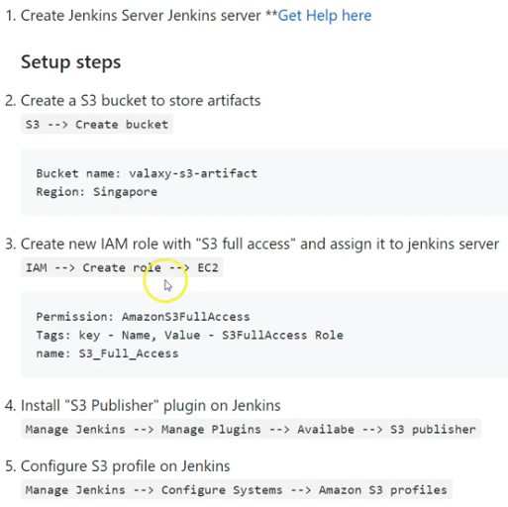



* Create IAM role on ec2 to access s3
* Now assign that role to Jenkins, we can find an option to attach or replace the role
* We can attach it even when the server is running
* Then download s3 publisher plugin in Jenkins
* Now, under configure system settings, we need to add s3 profile as below

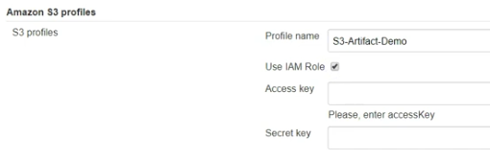

* If we have IAM role, we better assign that as above
* **If we want, we can also use access key and secret key of an user instead of role**
* Now under post build step, we need to select publish artifacts to s3 bucket as below

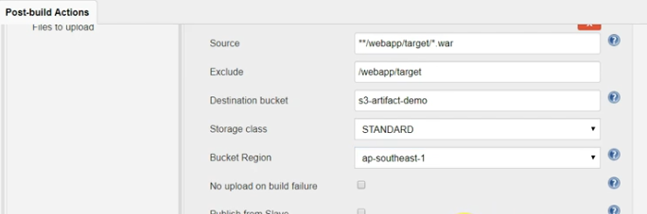

* Now the artifacts will get stored in s3 bucket. This way we can use it for storing the artifacts